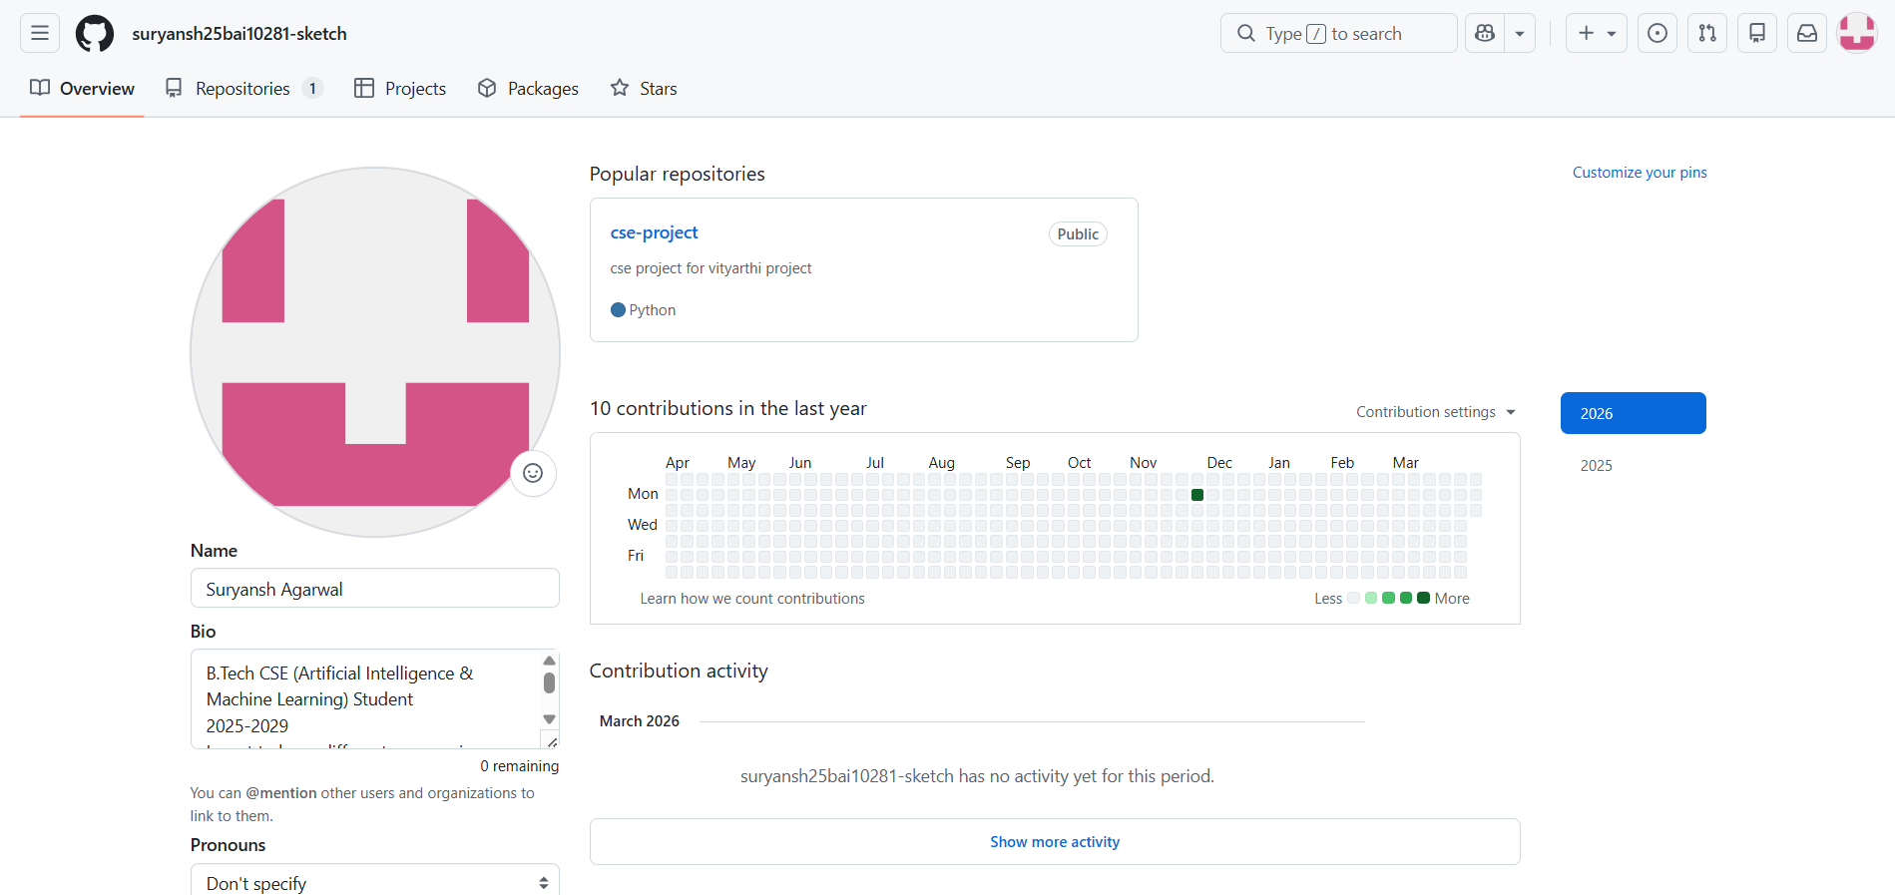

1. Establishing Credibility
The initial setup—adding a professional photo, a clear bio, and linking to a portfolio—serves as a first impression. In an industry where "show, don't tell" is the standard, a well-curated profile acts as a living resume. It demonstrates not just that I can code, but that I understand how to present my work to a global audience.
2. Organization and Narrative
Creating a README.md for the profile was a highlight of the process. It allowed me to move beyond raw data and narrate my journey. Deciding which languages to highlight and which projects to "pin" forced me to reflect on my current strengths and my future direction. It’s a tool for self-assessment: What do I want to be known for?
3. Transparency and Growth
The "Contribution Graph" is a powerful psychological tool. Setting up the profile creates a sense of accountability; seeing those green squares fill up is a visual representation of consistency. It also highlights the importance of version control—the realization that every mistake and iteration is part of a visible, healthy learning process.
4. Joining the Ecosystem
Finally, setting up the profile felt like "plugging in" to the open-source community. By following other developers and starring repositories, the profile stops being a static page and becomes a gateway to collaboration. It is a reminder that software development is a team sport, and I now have a uniform and a place on the field.
Key Takeaway: A GitHub profile is never "finished." It is an evolving reflection of my technical curiosity and my commitment to continuous improvement.
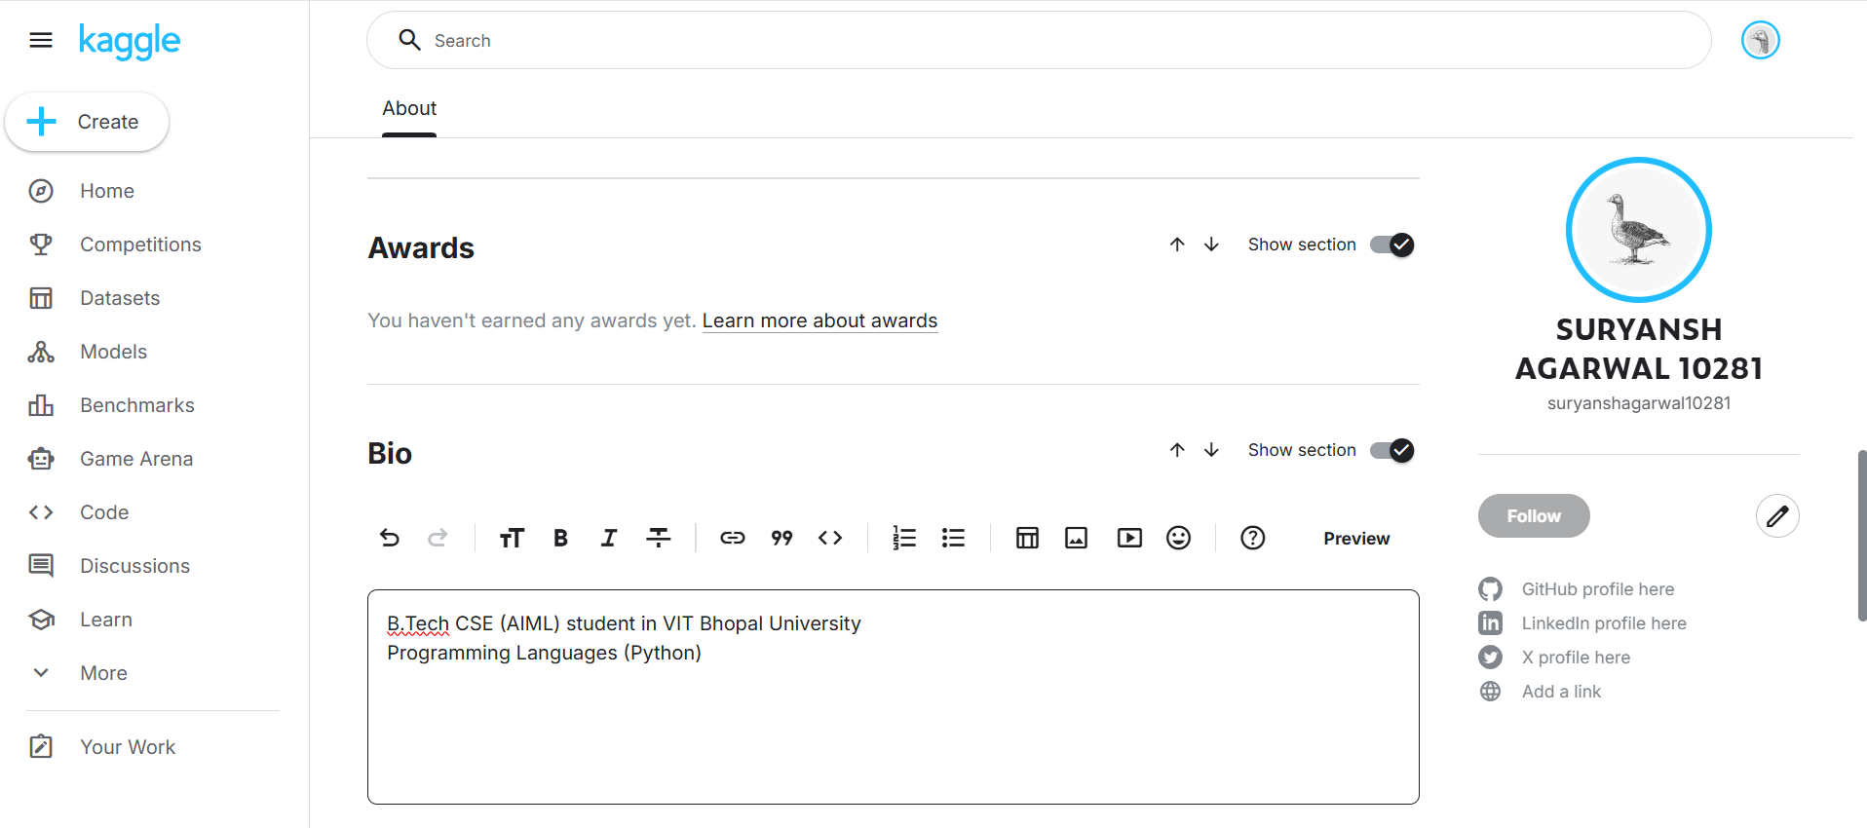
1. Defining a Data Identity
Initial setup—choosing a profile picture, linking a GitHub, and writing a bio—forced me to define my technical niche. Am I a computer vision enthusiast, a structured data specialist, or a budding NLP engineer? Kaggle provides the framework to showcase these interests through "Tiers" (Progression System), transforming a simple profile into a roadmap for professional growth.
2. The Power of Public Notebooks
The most significant part of the setup was understanding the Notebooks ecosystem. Unlike a private IDE, Kaggle encourages "coding in the open." Reflecting on this, I realized that my profile isn't just a portfolio; it’s a pedagogical tool. By publishing clean, well-documented code, I am contributing to a collective knowledge base while inviting feedback that accelerates my own learning.
3. Navigating the Dataset Goldmine
Setting up the profile meant diving into Kaggle’s massive repository of datasets. This highlighted the importance of data ethics and stewardship. Learning how to properly cite datasets and contribute my own clean data showed me that being a data scientist involves as much responsibility toward data quality as it does toward model accuracy.
4. Embracing the Competitive Edge
The "Competitions" tab can be intimidating, but setting up my profile felt like "entering the arena." It shifted my mindset from academic exercises to real-world constraints. Seeing the leaderboards served as a humbling yet motivating reminder that there are always more efficient ways to optimize a loss function or engineer a feature.

Final Thought
My Kaggle profile is a living record of my analytical curiosity. It’s where I prove that I can handle "messy" data and turn it into actionable insights. It serves as a bridge between theoretical knowledge and the practical, iterative reality of data science.

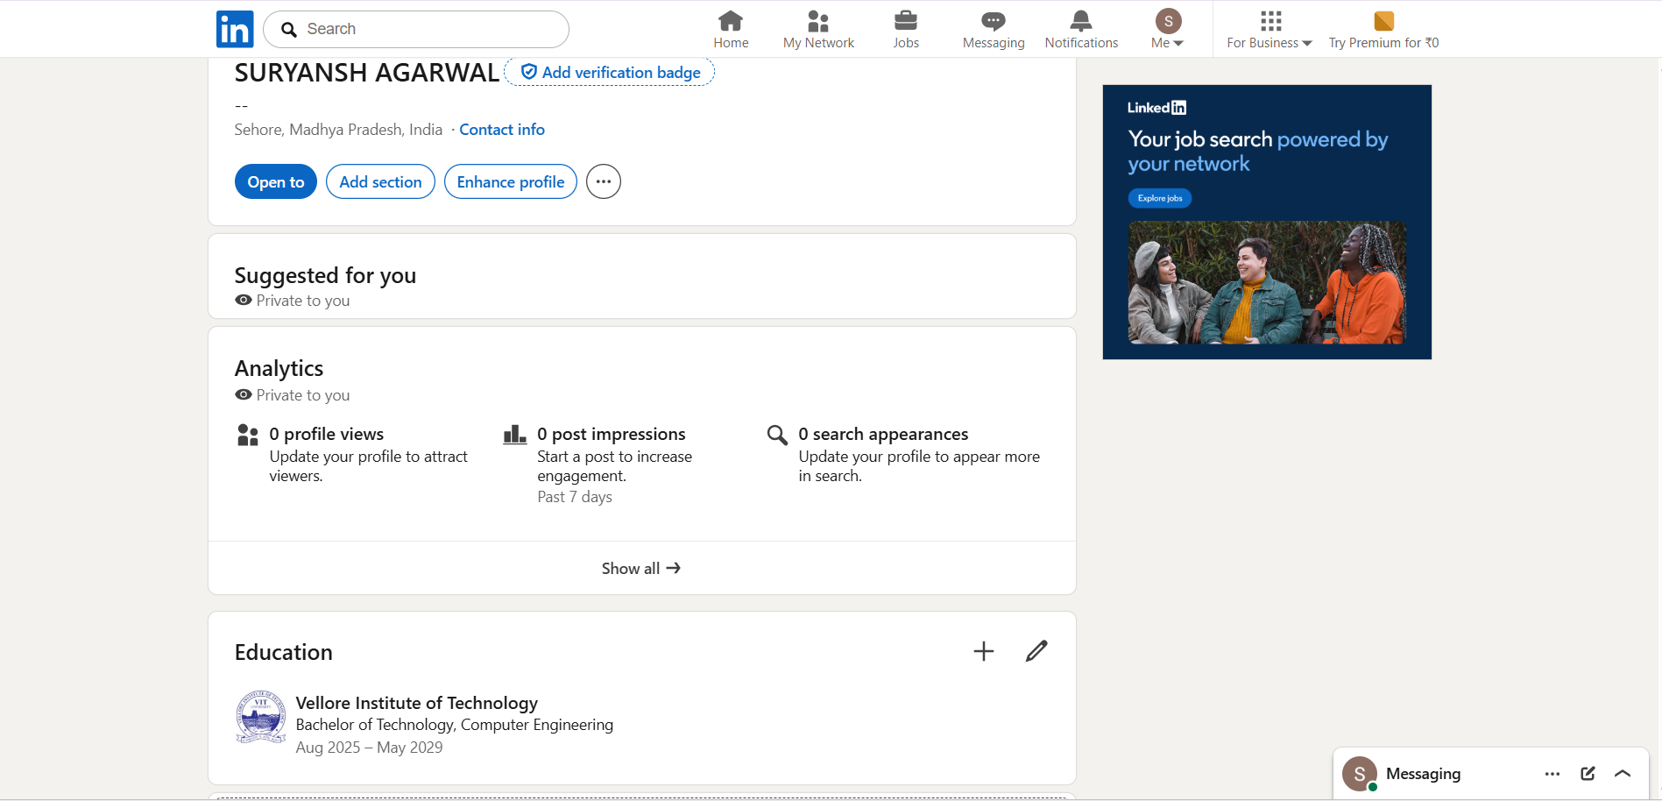
1. Defining a Personal Brand
The process of crafting a headline and "About" section forced me to distill my professional identity. It’s more than just a job title; it’s an exercise in "personal branding." I had to ask myself: What value do I bring to a team? What are my core drivers? Writing this narrative helped me gain clarity on my own career goals and how I want to be perceived by recruiters and peers.
2. The Living Resume
Unlike a static PDF resume, a LinkedIn profile is dynamic. Setting it up made me realize the importance of social proof. Adding skills is one thing, but seeking endorsements and displaying certifications provides a layer of institutional and peer-based credibility. It transformed my history from a list of dates into a vibrant record of achievements and continuous learning.
3. Intentional Networking
Setting up the profile felt like opening a door to a massive, professional "room." It highlighted that my network is a form of professional equity. By strategically connecting with industry leaders and following relevant companies, I shifted from a passive job seeker to an active participant in industry conversations.
4. The Digital First Impression
Choosing a professional headshot and a cohesive banner image served as a reminder that presentation matters. In a digital-first world, this profile is often the very first thing a potential employer sees. Ensuring that the tone is professional yet authentic is a delicate balance, but essential for building trust before a first meeting even occurs.

Key Takeaway: My LinkedIn profile isn't just an online CV; it’s my professional home base. It requires regular maintenance and engagement to remain a true reflection of my evolving career journey.

